# 3.Algorithm

Detection of blink can be evaluated by using Eye aspect Ratio (EAR) with OpenCV functions. Eye aspect Ratio is calculated using its formula with eye coordinates returned from OpenCV. Unexpected plunge in Eye aspect Ratio esteem against a set edge can be utilized for flicker location and microsleep recognition.

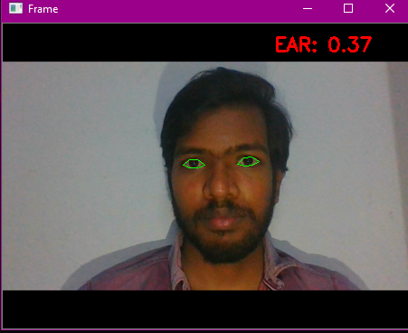

## **Figure-1:** outcome of facial Landmark detection, eye coordinate detection.

## **3.1Measurement of EAR**

### Each oculus is represented by hexad (a, b)-coordinate in watershed returned Dlib predictor role, start at the left-corner of the eye, and afterward working clockwise around the residuum of the district. There is a connexion between the width and the height of these focussing. Maker at that breaker point infer a circumstance that mirrors this joining called the eye angle proportionality.

### EAR (Eye aspect Ratio) =

Where p1, p2, ..., p6 are Two dimensional facial landmark.

The numerator of this term cash register the segregation between the upright eye milestone while the denominator processes the segregation between even eye tourist fleck, weighting the denominator suitably since there is just one stack of flat focal point however two arrangements of vertical focuses. At the point when the individual flickers the eye perspective proportion diminishes significantly, moving toward zero. Eye perspective proportion is steady, at that point quickly drops near zero, at that point increments once more, showing a solitary squint has occurred.

Def e_a_r(S,eye): # python ear compute

X= dist.euclidean(eye[1],eye[5])

Y = dist.euclidean(eye[2],eye[4])

Z = dist.euclidean(eye[0],eye[3])

ear = (X + Y) / (2.0 * Z)

return ear

**Algorithm for eye blinking detection**

if ear < EAR_Threshold:

COUNT += 1

if ear < EAR_Threshold:

D_BAR+=10 if ear>

Threshold: D_BAR=0

if COUNT > 2: # Eye Blinks

Detection

if ear > Threshold:

TT +=1 #Total

COUNT=0

if D_BAR>TD_BAR: # Microsleep Detection

DEVENT+=1

# In the event that regardless EAR drops under than set bound and stays for at any rate one second. It is distinguished as flicker and COUNT stores estimation of strabismus. Assuming further, EAR remains under than demarcation line for in excesssiveness of 3 it is considered as doze and will be shown on languor plate and DEVENT changeable stores no of sluggishness occasions. Legitimate rationale to stay away from bogus flicker identification is execute by creator.

# 3.2 EAR PLOT

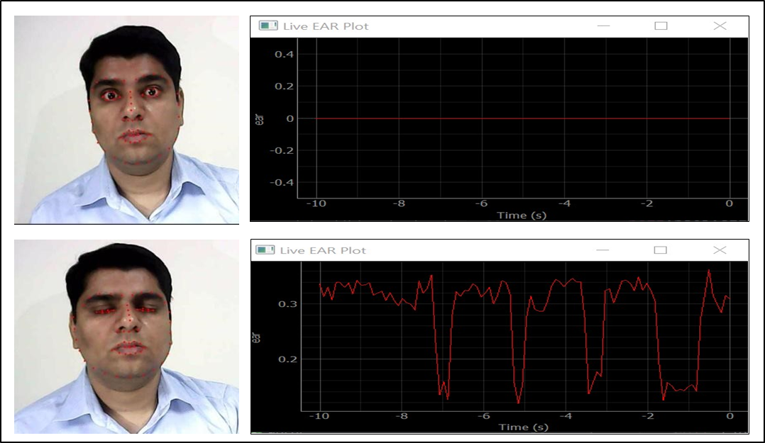

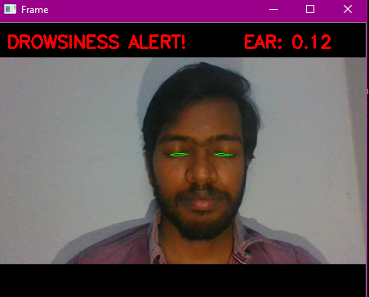

**Figure 2:** Simulation of evaluated EAR value for open and closed eye.